Working Notes of Alizeti in Home

#### Saturday, August 5, 2017

1.

STM32F103xx AC induction motor IFOC software library V2.0 (UM0483)

STM32 and STM8 Flash Loader demonstrator (UM0462

#### Sunday, August 6, 2017

### 1。http://www.doc88.com/p-0939785255113.html [基于STM32的PMSM_FOC软件库培训my](https://www.baidu.com/link?url=b_uByDWn8L3O-zAun-65Wg-xuBL7N3gmH0DJWEwTENg1Y8VO1TE3qCbpTJICNbKP8M5hluSSuqsYlgdoZ26YNa&wd=&eqid=e82be4610001c6120000000459874022)

https://wenku.baidu.com/view/b9504013bb4cf7ec4bfed03e?pu=

### 2。http://m.wenkuxiazai.com/doc/7d35d4fab9f3f90f76c61b61.html，基于STM32的PMSM_FOC软件库培训

3. http://m.wenkuxiazai.com/doc/ac12d91c5f0e7cd18425360b.html

4. http://www.doc88.com/p-0939785255113.html good!!! (5.6............. High Frequency ,,,,,

5. https://wenku.baidu.com/view/4453e03987c24028915fc3dc.html?re=view

It executes - in sequence- the low frequency tasks related to each of drives

#### Saturday, August 12, 2017

1. Buffered Command

MCI_ExecSpeedRamp: START_RUN, RUN

MCI_ExecTorqueRamp: START_RUN, RUN

MCI_SetCurrentReferences: START_RUN, RUN

#### Sunday, August 13, 2017

# 1. Sensorless rev-up : 16 min ofSTM32 PMSM FOC SDK V3 2 讲座5

2. **讲座6**How to create user project interacting with MC Application

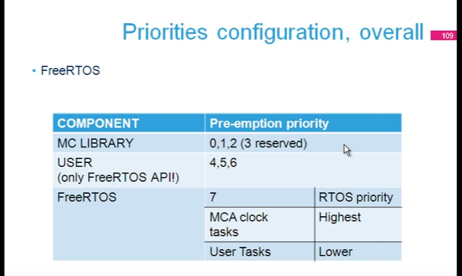

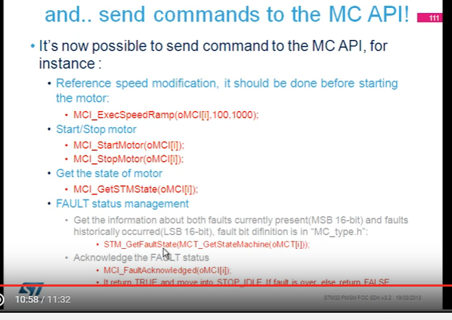

MCTask touch PWMnCurrentFdb API with function PWMC_SwithOnPWM

Monday, March 29, 2021

